Using HWB – J2 data can you create a selection of pictograms and bar charts using a range of data?
You may want to ask your family about their favourite foods/hobbies/colours/animals. Can you challenge yourself and ask them in Welsh?
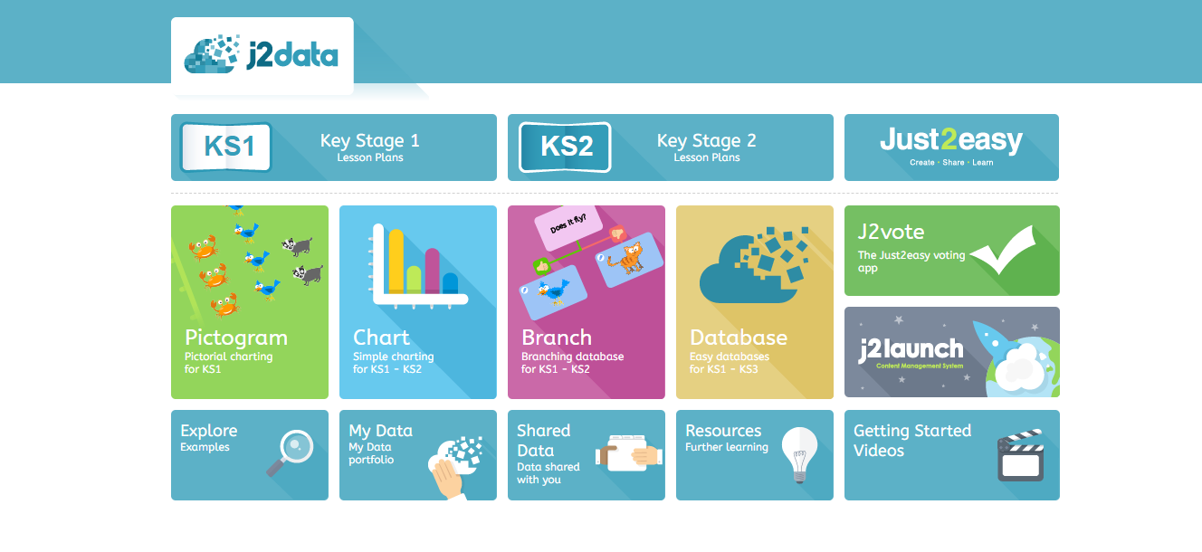
You could also do research from the internet, for example how many languages are spoken in different countries?
I would love to see your pictograms and bar chats saved on your HWB learning space.
Remember to keep using the times table blaster on HWB, staying home and safe is a great opportunity to boost your score. I can not wait to see how many points you can win!

